EXPERIMENT 1:

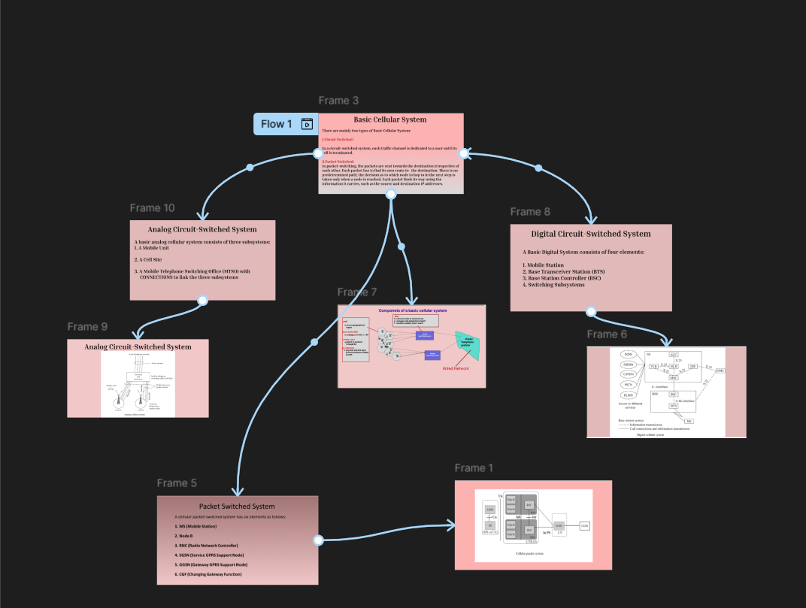

EXPERIMENT 2:

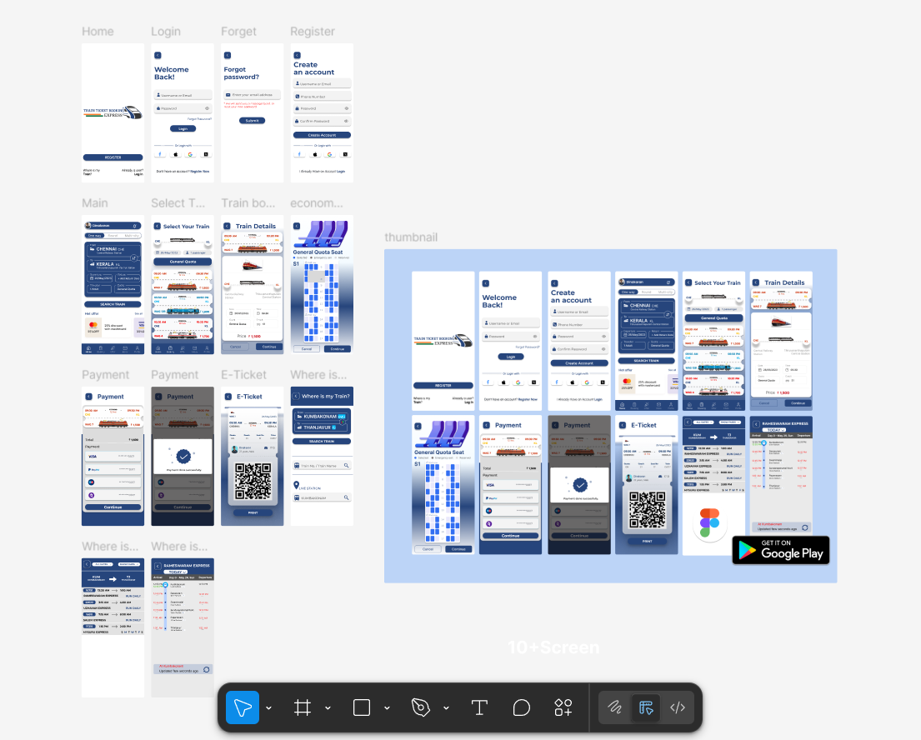

EXPERIMENT 4:

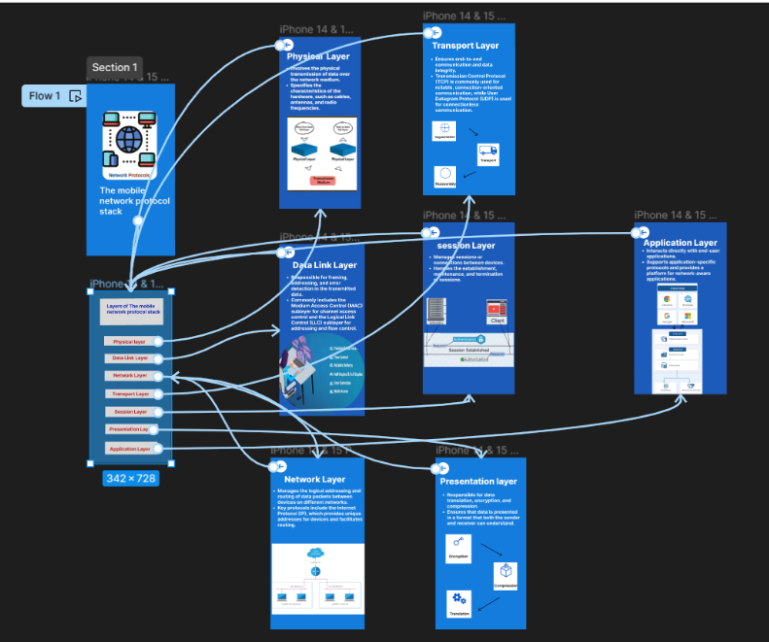

EXPERIMENT 5:

EXPERIMENT 6:

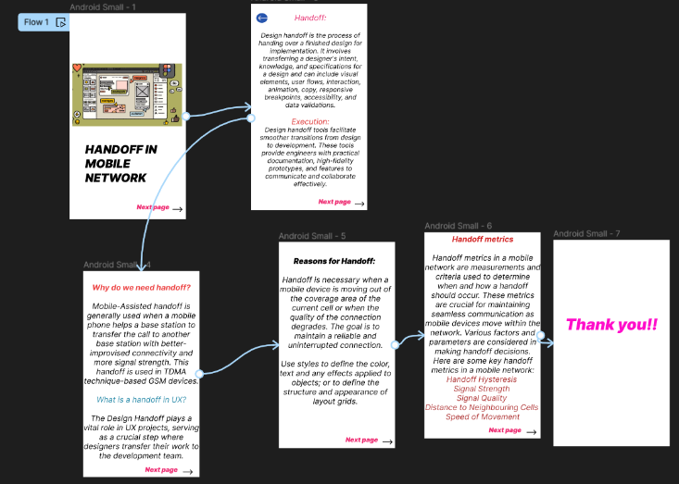

EXPERIMENT 7:

EXPERIMENT 8:

EXPERIMENT 9:

EXPERIMENT 10:

EXPERIMENT 11:

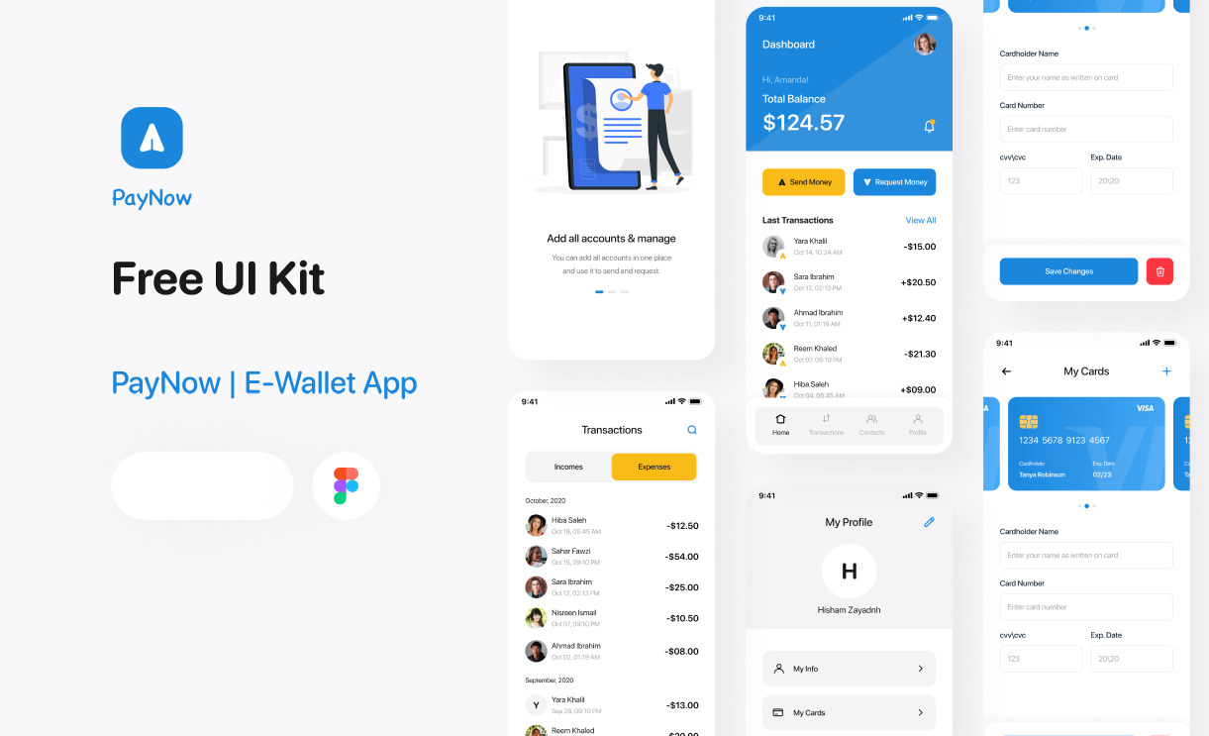

EXPERIMENT 12:

EXPERIMENT 13:

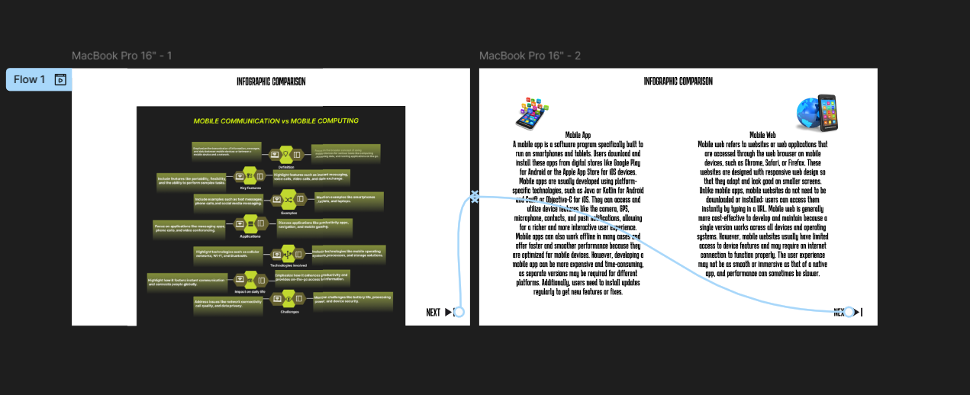

EXPERIMENT 14:

EXPERIMENT 15:

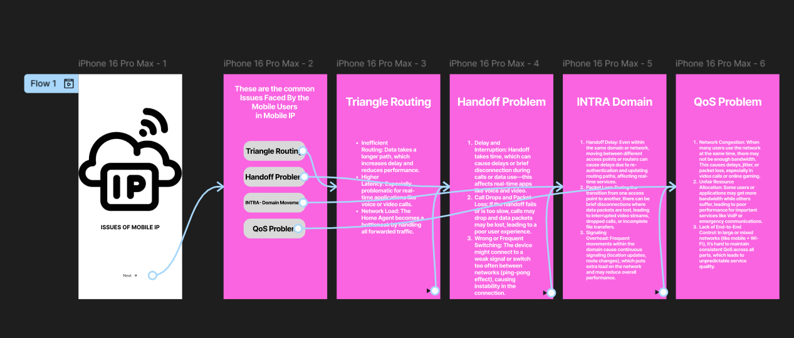

EXPERIMENT 16:

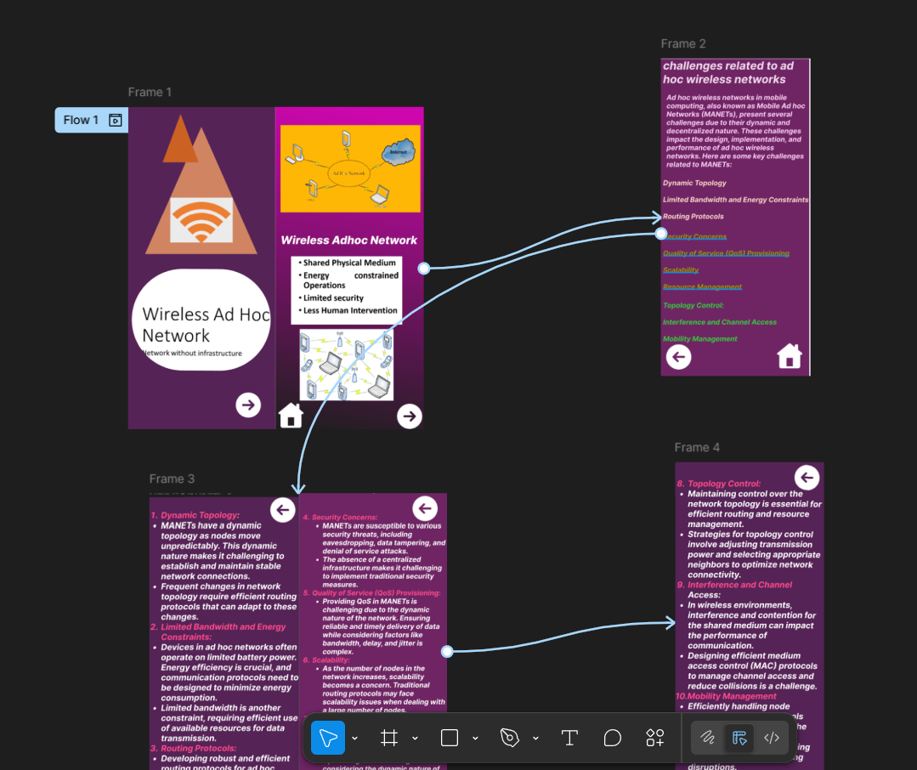

EXPERIMENT 17:

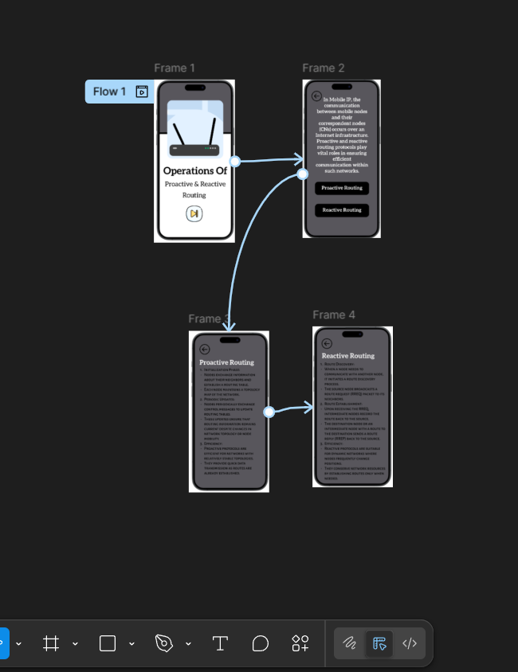

EXPERIMENT 18:

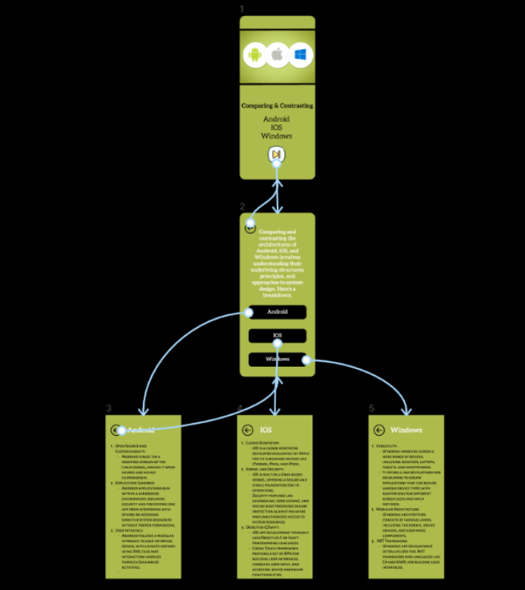

EXPERIMENT 19:

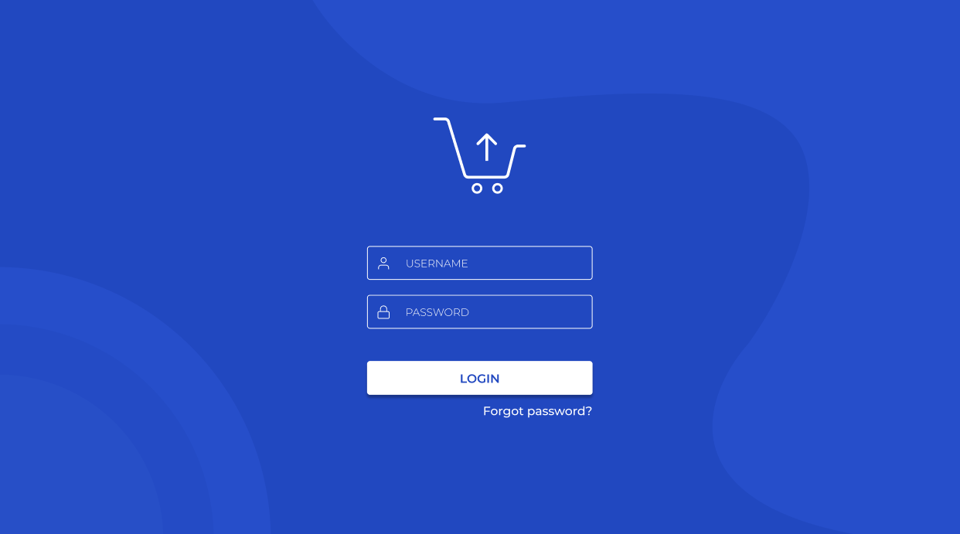

EXPERIMENT 20:

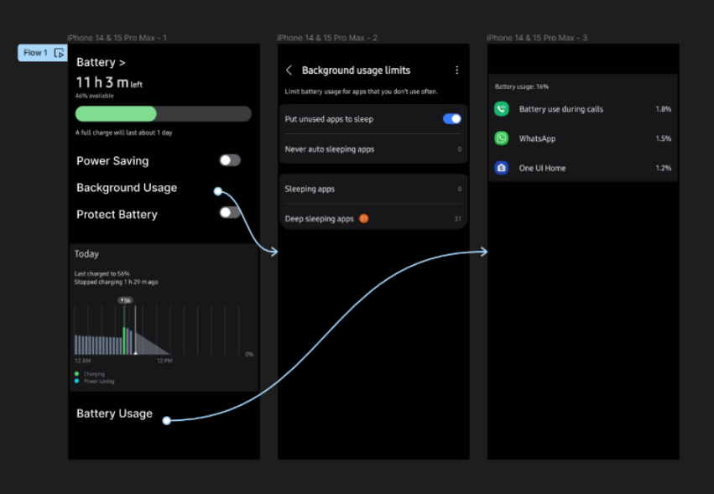

EXPERIMENT 21:

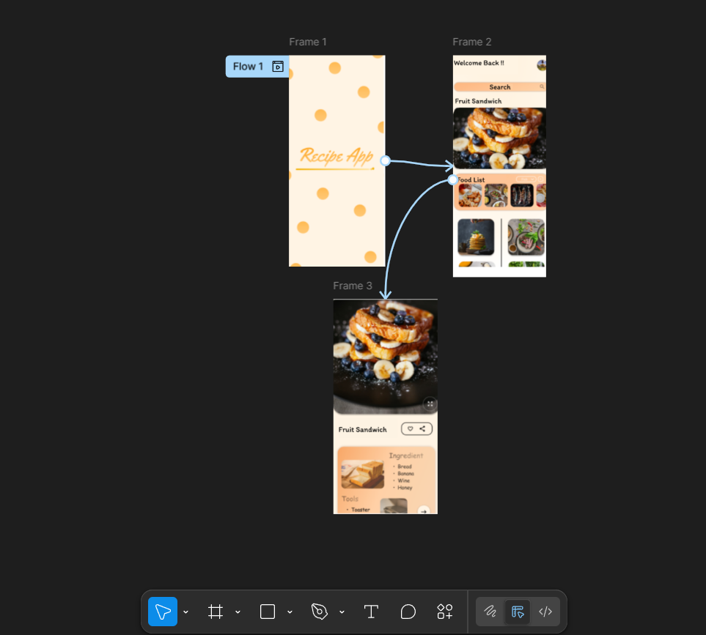EXPERIMENT 22:

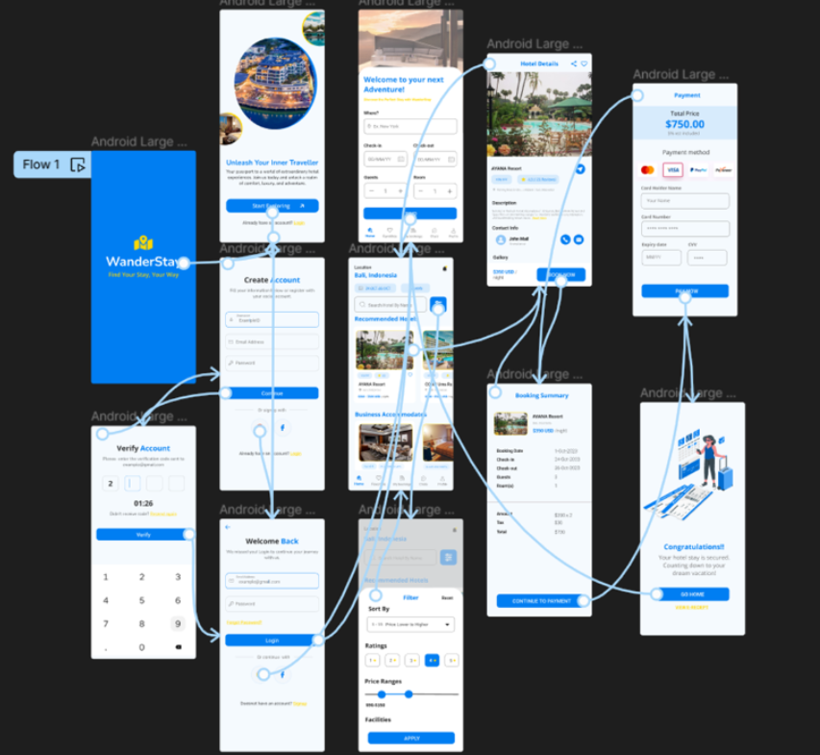

EXPERIMENT 23:

EXPERIMENT 24:

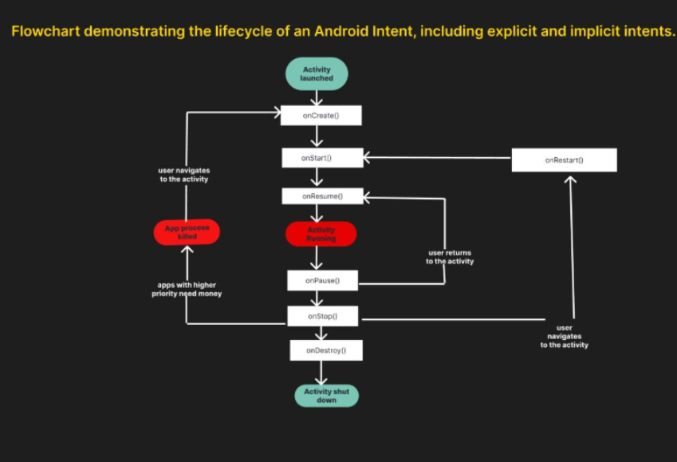

EXPERIMENT 25:

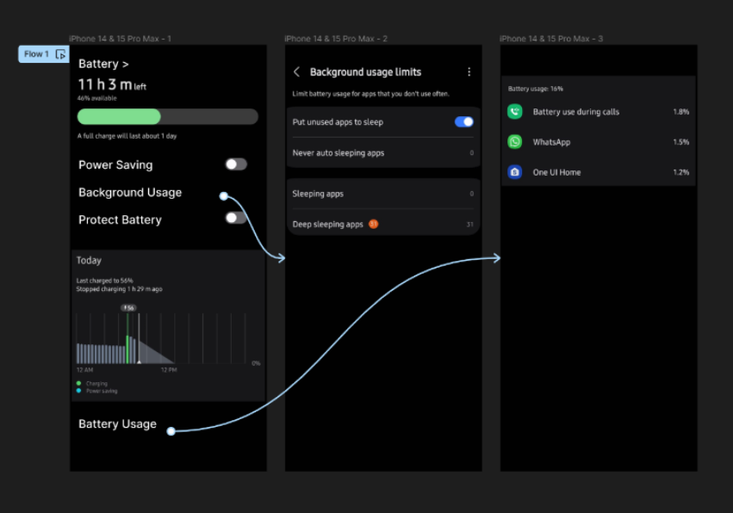

EXPERIMENT 26:

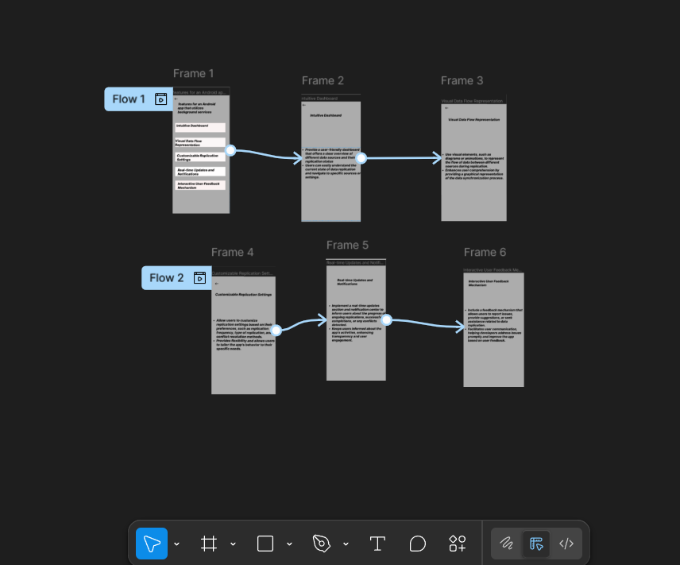

EXPERIMENT 27:

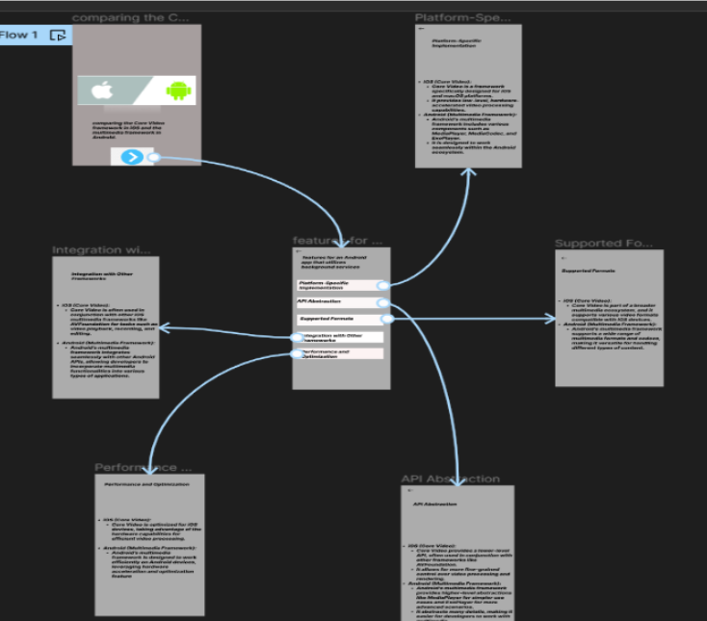

EXPERIMENT 28:

EXPERIMENT 29:

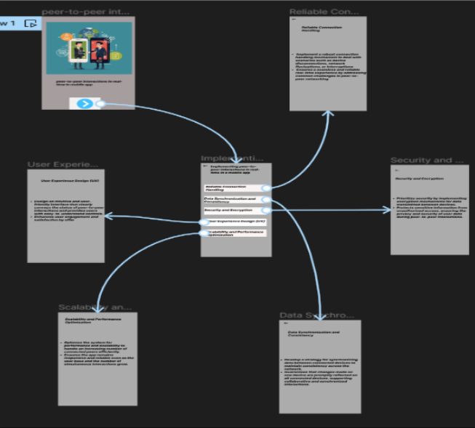

EXPERIMENT 30:

